**Negotiation Chatbot using OpenAI Model**

**Problem Statement**:

The goal is to create a negotiation bot with an pre-trained AI model, in this project we build the bot with OpenAI.

**Objective**:

Create a chatbot that simulates a negotiation process between a customer and a supplier, leveraging pre-trained models like Gemini, ChatGPT, or other AI language models.

**Model**:

In this model to negotiate the price of the user, Here we incorporated a pre trained OpenAI model (ChatGpt) to handle the conversational aspect of the negotiation.

While integrating the OpenAI with Python we need to generate OpenAI api key to use the pre trained OpenAI model for our chatbot with our specification.

The OpenAI provides 3 roles

* System (is used to generate a mindset about our bot to openai)
* User (users prompt for the OpenAI model)
* Assistant (is the OpenAI model)

Defined 4 functions for Negotiation chatbot to respond with user prompts and system.

* **Initiate_conversation**: In this function initiated a conversation with openai providing two roles system , assistant making the bot for our convenience provided with the role.
* **Negotiate_with_ai**: Here created a OpenAI model of “gpt-4” as our negotiation bot the prompts from the user runs with this type of model from openai and returns the response we can also use other models like gpt -3,3.5 or flash.
* **Evaluate_user_offer** : In this Function we define the Initial price of the product ,minimum acceptable price, Maximum discount range and the bot offer. Logic to evaluate the user offer and provide a counter offer or accept/reject.
* **Chatbot_conversation**: this is the main function which calls all the 3 pre-defined function, gets the user input and we extract only the amount mentioned and evaluate the offer from the user by accessing the evaluate offer function it gets the response and generate it as bot response if the the user amount is accepted it terminates the loop or from the evaluation function it tends to give an offer to the user to accept.this loop runs till it finds the best offer for the user, if there is a non price prompt then the except function calls the OpenAI model to continue the conversation.

To check the working of the Bot ,Initially created a simple bot(role :data scientist).Also attached a snip of the models working for reference:

Simple bot (Role:DataScientist):

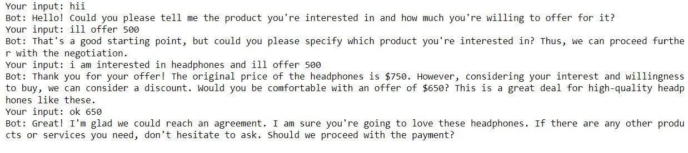

Negotiation Bot Output: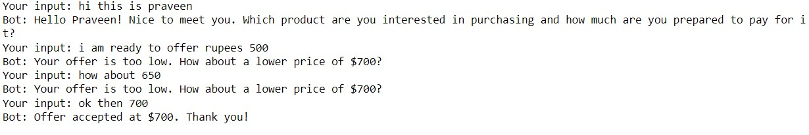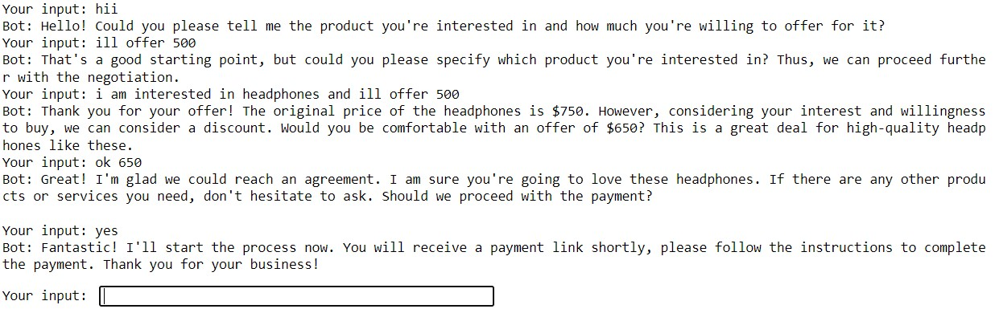

**Chatbot with Sentiment Analysis**:

With addition to the Negotiation Bot Defined another function to analyse the sentiment from the user and based on it the bot offers an extra discount if the user is polite if not it uses the usual amount

For this imported NLTK(Natural language toolkit) library for sentiment analysis this determines the sentiment or emotional tone behind pieces of text and we extracted the polarity scores from the user and stored in sentiment variable and if the value exceeds 0.5 value then we determine the user is polite and offer a discount 50rupees, and followed by the same process as negotiation bot but it needs to be tuned more efficiently.

**Working :**

